

**GIT HUB**

FACULTY: DR D GANESHA



**ASSIGNMENT**

**-**

**B**

**1**

4

SUBMMITED BY:

JEEVAN H

433IS22020

**ASSIGNMENT-1B**

**GIT HUB**

**Why Do We Need a Version Control System?**

Version control systems allow multiple developers, designers, and team members to work together on the same project. It helps them work smarter and faster! A version control system is critical to ensure everyone has access to the latest code and modifications are tracked. **Fundamentals of Git**

1. Working Directory
2. Staging Area
3. Local Repository
4. Remote Repository



# Difference between Git and GitHub

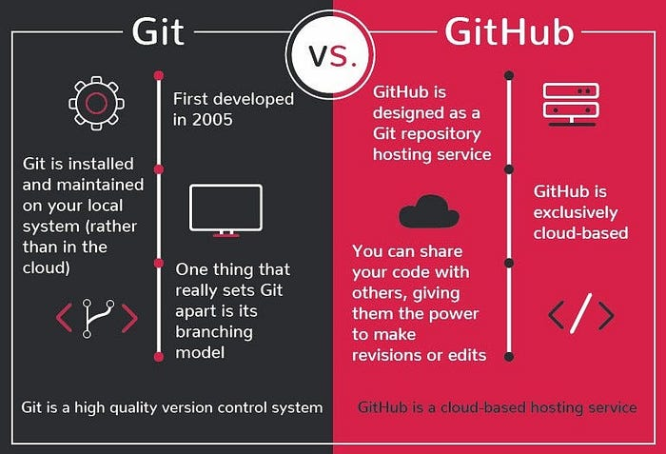

# INSTALLING OF GIT BASH

**STEP-1:** Download the latest version of git and choose the 64/32 bit version. After the file is downloaded, install it in the system. Once installed, select Launch the Git Bash, then click on finish. The Git Bash is now launched.

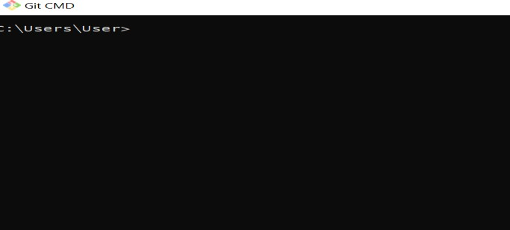

**STEP-2:** Check the Git Version

Command: Git --version

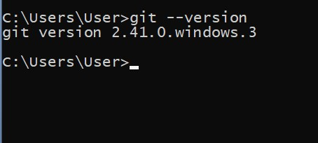

**STEP-3:** This command will lead you to a browser of config commands. Basically, the help the command provides a manual from the help page for the command just following it. (Here, it’s config)

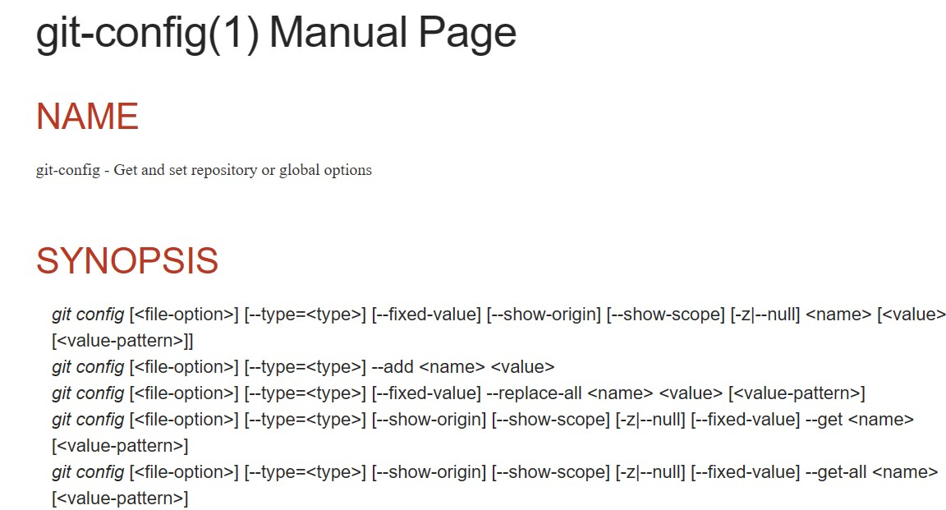

**STEP-4:**To set your Git username, run the Git config --global user.name command.

You should specify both your first and last name but your username can be anything you want to your commits.

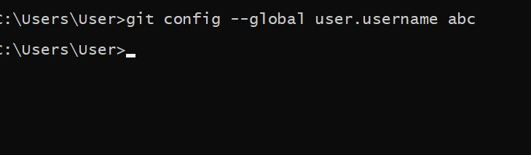

**STEP-5:** Create a local directory using the following command:

**$ mkdir file_name**

**$ cd**

**STEP-6:** The next steps is to initialize the directory:

# $ git init

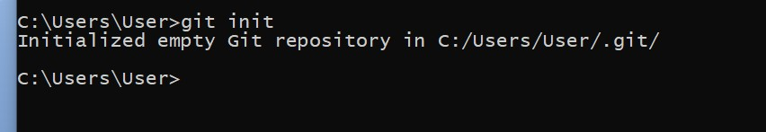

Installing of Git Hub

**STEP-1:** Visit the google play store.

**STEP-2:** Search for GitHub.

**STEP-3:** Then GitHub will appear.

**STEP-4:** Click on install.

**STEP-5:** Wait until it download.

**STEP-6:** When the installation is complete**.**

**STEP-7:** Click on open.

# Creating account in GitHub

**STEP-1:** Once the installation done open it.

**STEP-2**: Create GitHub tool**.**

**STEP-3:** The screen opens.

**STEP-4:** Click on the signup for GitHub.

**STEP-5:** Enter your email.

**STEP-6:** Click on continue.

**STEP-7:** Enter the password**.**

**STEP-8**: Click on next**.**

**STEP-9**: Enter a user name.

**STEP-10:** To get update via email click ‘yes’ or ‘no’.

**STEP-11**: If yes, It show puzzles click on start puzzles.

**STEP-12:** After verified completely.

**STEP-13:** Click on create account.

**STEP-14**: Enter the code which is sent to your email.

**STEP-15**: Copy the code from the mail.

**STEP-16**: And paste it, click enter.

**STEP-17:** You are successfully login to GitHub.

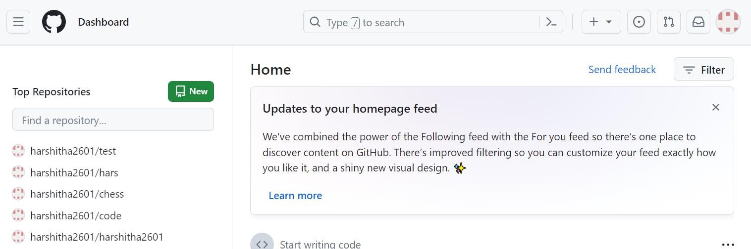

## CREATING REPOSITORY

**STEP-1:** Install GIT HUB if you have not installed.

**STEP-2**: Once you have created account in GitHub.

**STEP-3:** On top right side click on the plus (+) symbol**.**

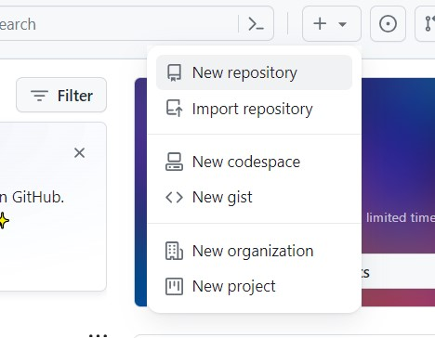

**STEP-4:** Choose new repository**.**

**STEP-5**: Enter the new repository name**.**

**STEP-6**: Choose whether to show private or public**.**

**STEP-7:** Click on create a new repository**.**

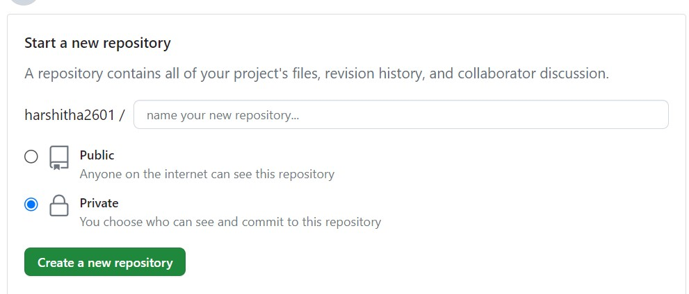

**STEP-8:** Once you have created the repository click on create new file**.**

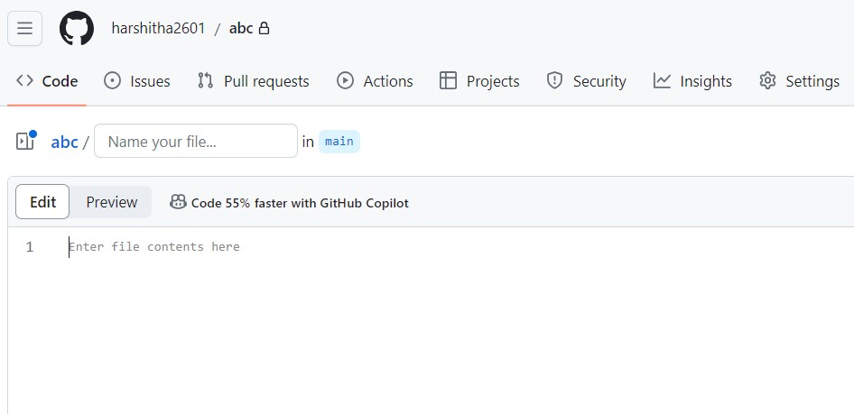

**STEP-9:** Add the code.

**STEP-10:** Save the code.

**STEP-11:** And post it.

**STEP-12:** Only the private people in your list can see what is there in private repository.

**STEP-13:** If you switch/save it in public, then people can see what is there in public repository.

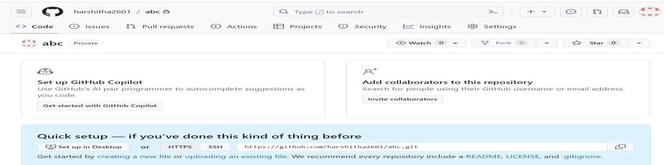

## PUSHING TO REPOSITORY

**STEP-1:** First create the repository**.**

**STEP-2:** After creating repository, click on upload files.

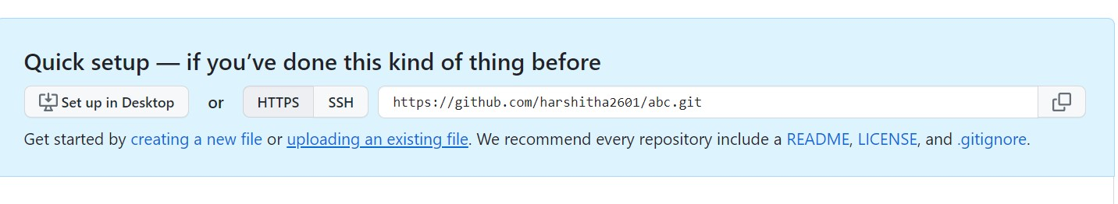

**STEP-3:** Click on choose your files.

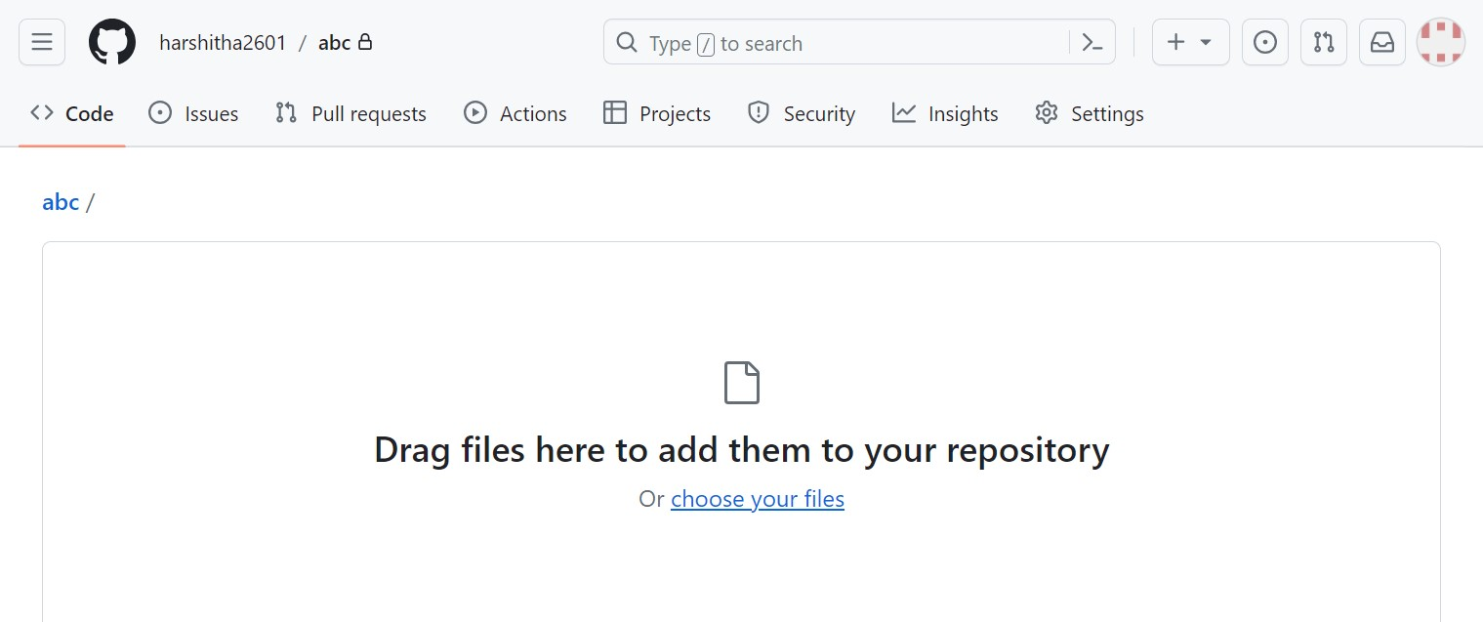

**STEP-4:** Select the file that need to be push into the repository**.**

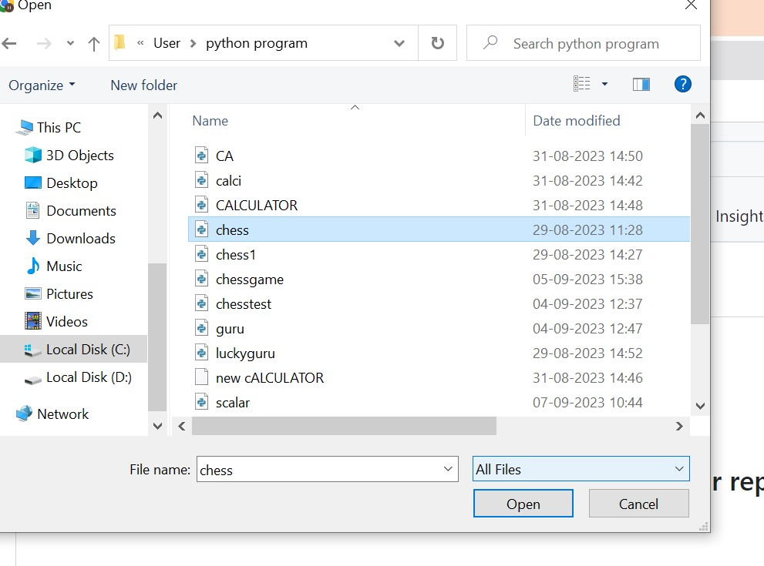

**STEP-5:** After selecting the file, the file will get uploaded.

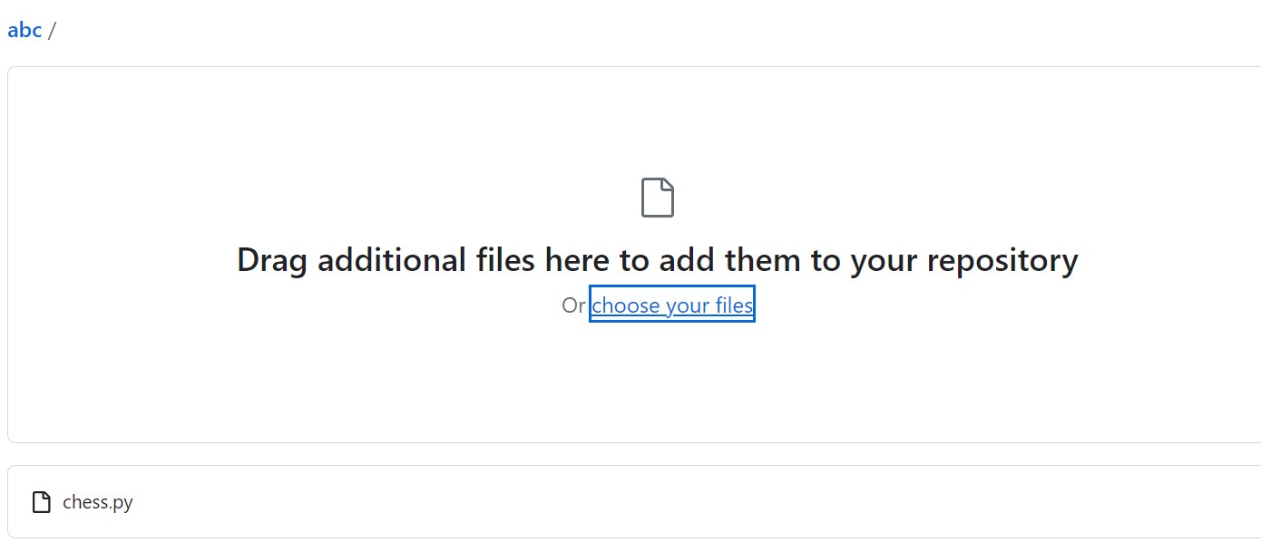

**STEP-6**: Click on commit changes to upload your file.

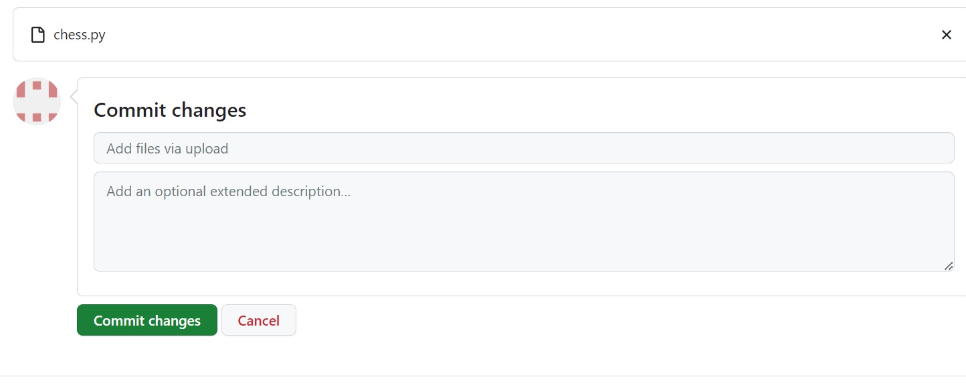

**STEP-7:** The file will get pushed into the repository.

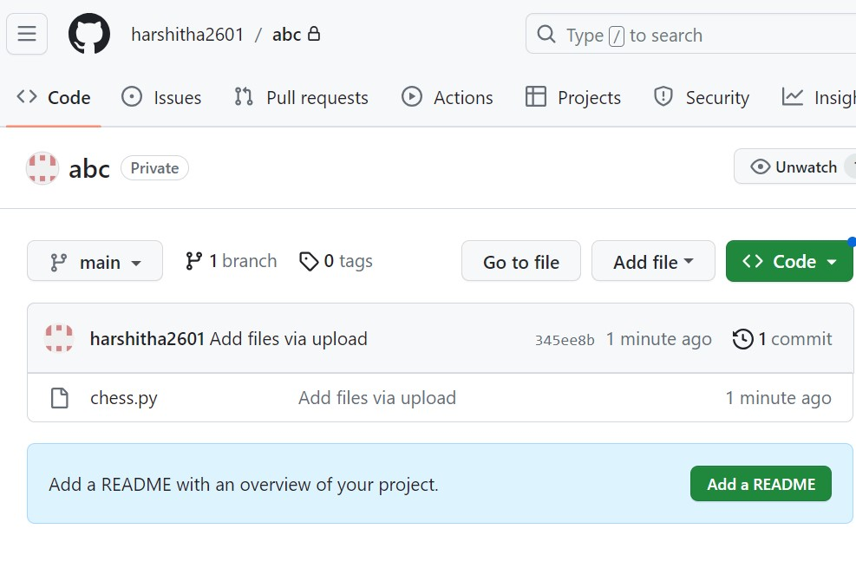

**STEP-8:** Now the file that has been pushed into your repository you can view it.

